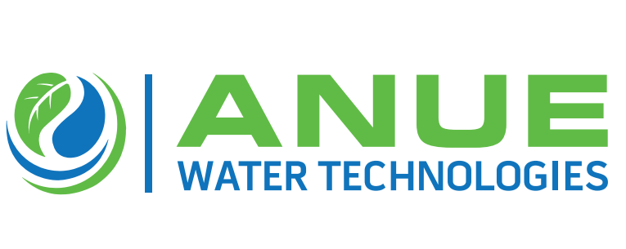
Anue Water Names JH Wright as Exclusive Channel Partner for Gulf States, Florida Panhandle & Georgia

(Tucker GA – November 25, 2020 — Anue Water Technologies, the manufacturer of cost- effective FORSe and Phantom Oxygen/ Ozone injection systems, Enviroprep well-washers, and provider of Anue Geomembrane Covers with embedded carbon-filters and other sustainable and high-performance technologies to prevent odor, corrosion, scale, bacteria, and FOG (fat oil, grease) in municipal and industrial wastewater applications, is announcing that J.H. Wright & Associates is the exclusive new channel partner for the sales and distribution of Anue’s eco-friendly product line throughout the Gulf States of Louisiana, Mississippi, Alabama, the Florida Panhandle and Georgia.

According to Greg Bock, Anue Water VP General Manager, “We are happy and excited to have J.H. Wright & Associates as our exclusive channel partner throughout this large and important region. J.H. Wright has a 60 year history of leadership in the wastewater treatment industry, a truly great team of process technology experts and a high-level of energy and enthusiasm for solving customer problems.”

Mark Wright, President of J.H. Wright & Associates declared,” Taking on Anue Water’s clean-tech product line is an important milestone in JH Wright’s long history of service to the municipal, industrial and process water industry. Partnering with Anue Water Technologies enables us to offer clean oxygen/ozone injection systems that pay for themselves in terms of chemical, labor and other operating cost-savings over a 2 – 3 year period. Anue’s FOG busting Enviroprep well-washers and odor eliminating Geomembrane Covers with embedded carbon-filters will also be very popular in the Southeast region of the US.”.

Anue Water CEO Paul Turgeon added, “We are very proud to have the J.H. Wright team as our exclusive channel partners. I’m very optimistic about what we can do together to solve customers’ wastewater problems throughout the Gulf States, the Florida Panhandle and Georgia.”

About Anue Water Technologies: Founded in 2005, Anue Water Technologies Inc. is headquartered in Tucker GA. The company manufactures and supplies eco-friendly, high efficiency, patented systems for the municipal and industrial wastewater markets, including oxygen/ozone injection, well-washers and carbon-embedded geomembrane covers for odor, corrosion and FOG (fats, oil, grease) control. For more information, contact Anue Water Technologies, Inc. at sales@anuewater.com or (760) 727-2683 or visit our web site at www.anuewater.com.

About JH Wright: Since 1961 J.H. Wright & Associates has been delivering municipal, industrial, and process fluid handling solutions to customers throughout the Southeast. We pride ourselves on dependable service with integrity. We provide technical expertise, 24-hour service and on-time delivery, so whatever your fluid-handling needs, we’ve got the “Wright” solution.

