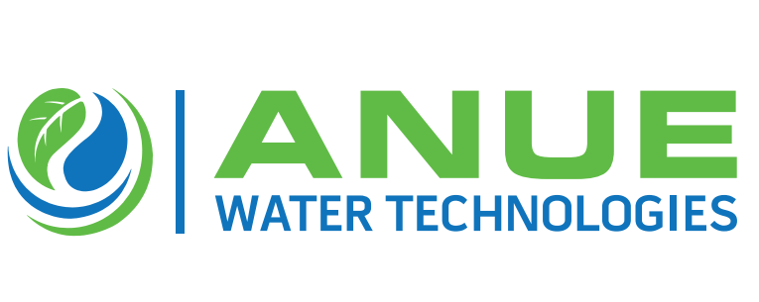

**Anue Water Names Northwestern Power Equipment Company Exclusive Channel Partner for Upper Midwest States**

**(Alpharetta, GA – January 21, 2021 —** Anue Water Technologies, the manufacturer of cost- effective FORSe and Phantom Oxygen/ Ozone injection systems, Enviroprep well-washers, and provider of Anue Geomembrane Covers with embedded carbon-filters and other sustainable and high-performance technologies to prevent odor, corrosion, scale, bacteria, and FOG (fat oil, grease) in municipal and industrial wastewater applications, is announcing that Northwestern Power Equipment Company is the exclusive new channel partner for the sales and distribution of Anue’s eco-friendly product line throughout the Upper Midwestern Region of the US, including Minnesota, North and South Dakota, and Western Wisconsin.

According to Greg Bock, Anue Water VP General Manager, “We are very excited to bring our eco-friendly wastewater treatment equipment to market in the Upper Midwestern Region of the US through Northwestern Power Equipment, a most highly regarded company serving municipal wastewater customers successfully since 1939. Northwestern Power Equipment has an 80-plus year history of leadership in the wastewater treatment industry, some of the industry’s most outstanding experts in process technology, with a focus on finding the root cause of the customer’s problem and solving it.”.

Don Kluck, President of Northwestern Power Equipment stated,” Representing Anue Water’s clean-tech product line is an important milestone in our long history of service to the municipal and process water industry in the Upper Midwestern States . Partnering with Anue Water Technologies enables us to offer clean oxygen/ozone injection systems with remote digital telemetry that pay for themselves in terms of chemical, labor and other operating cost-savings over a 2 – 3 year period. Anue’s FOG busting Enviroprep well-washers and odor eliminating Geomembrane Covers with embedded carbon-filters will also be very popular solutions in the Upper Midwest Region of the US.”.

Anue Water CEO Paul Turgeon added, “We are very proud to have Northwestern Power Equipment Company as our exclusive channel partners. I’m very optimistic about what we can do together to solve customers’ wastewater problems throughout the States of Minnesota, North and South Dakota, and Western Wisconsin.”.

**About Anue Water Technologies:** Founded in 2005, Anue Water Technologies Inc. is headquartered in Tucker GA. The company manufactures and supplies eco-friendly, high efficiency, patented systems for the municipal and industrial wastewater markets, including oxygen/ozone injection, well-washers and carbon-embedded geomembrane covers for odor, corrosion and FOG (fats, oil, grease) control. For more information, contact Anue Water Technologies, Inc. at [sales@anuewater.com](mailto:sales@anuewater.com) or (760) 727-2683 or visit our web site at [www.anuewater.com.](http://www.anuewater.com/)

**About Northwestern Power Equipment Company (NWPE_):** Since 1939,NWPE is providing equipment for municipal wastewater, water, fire protection and industrial applications. NWPE serves Minnesota, North Dakota, South Dakota, Iowa and Wisconsin.