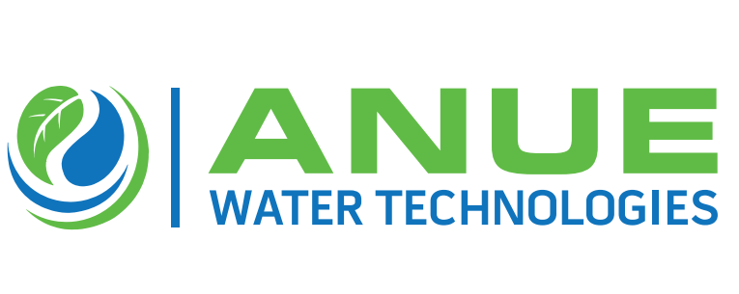
Anue Water Relocates To Larger Atlanta-based HQ & Manufacturing Facilities Due To Record Growth, Municipal Demand for Eco-Friendly Wastewater Equipment Solutions

(Alpharetta, GA – January 6, 2020 — Anue Water Technologies, the manufacturer of cost- effective FORSe and Phantom Oxygen/ Ozone injection systems, Enviroprep well-washers, and provider of Anue Geomembrane Covers with embedded carbon-filters and other sustainable and high-performance technologies to prevent odor, corrosion, scale, bacteria, and FOG (fat oil, grease) in municipal and industrial wastewater applications, is announcing the relocation of its headquarters and manufacturing from Tucker, Georgia to a substantially larger facility in the North Atlanta suburb of Alpharetta, Georgia.
The relocation is due to record growth during 2020 for Anue Water’s eco-friendly wastewater and other odor, corrosion and FOG (fats, oil, grease) control products, along with the projected demand for these clean-tech solutions moving forward into 2021.

According to Anue Water’s VP General Manager Greg Bock, “The new facilities in Alpharetta will enable us to prepare more equipment and ship it out more quickly to municipal and industrial customers throughout the US, Canada and the rest of the world. “.

Anue Water CEO Paul Turgeon added, “The need for larger facilities springs from consumer and regulatory demands for more environmentally friendly solutions to odor, corrosion and FOG problems. Anue’s recent addition of several new channel partners in the Gulf States, Florida Panhandle, Pennsylvania, West Virginia, New Jersey, Indiana and the Upper Midwestern States are also creating new demand by introducing Anue Water’s eco-friendly equipment solutions to many more municipal and industrial customers.”

About Anue Water Technologies: Founded in 2005, Anue Water Technologies Inc. is headquartered in Tucker GA. The company manufactures and supplies eco-friendly, high efficiency, patented systems for the municipal and industrial wastewater markets, including oxygen/ozone injection, well-washers and carbon-embedded geomembrane covers for odor, corrosion and FOG (fats, oil, grease) control. For more information, contact Anue Water Technologies, Inc. at sales@anuewater.com or (760) 727-2683 or visit our web site at www.anuewater.com.

