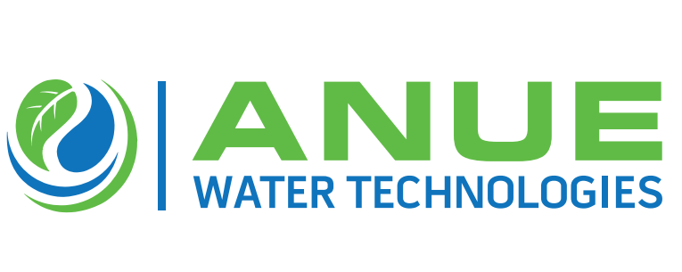

**Anue Water Chooses Kershner Environmental Technologies as Exclusive Channel Partner for Pennsylvania and New Jersey**

**(Alpharetta, GA – January 11, 2021 —** Anue Water Technologies, the manufacturer of cost- effective FORSe and Phantom Oxygen/ Ozone injection systems, Enviroprep well-washers, and Anue Geomembrane Covers with embedded carbon-filters and other sustainable and high-performance technologies to prevent odor, corrosion, scale, bacteria, and FOG (fat oil, grease) in municipal and industrial wastewater applications, is announcing that Kershner Environmental Technologies is the exclusive new channel partner for the sales and distribution of Anue’s eco-friendly product line in Eastern and Central Pennsylvania, as well as Central and Southern New Jersey.

According to Greg Bock, Anue Water VP General Manager, “We are happy and excited to have Kershner Environmental Technologies as our exclusive channel partner throughout this large and important region. Kershner Environmental has an excellent history of leadership in the wastewater treatment industry, a truly great team of process technology experts and a high-level of energy and enthusiasm for solving customer problems.”

Rob Kershner, President of Kershner Environmental declared,” Taking on Anue Water’s clean-tech product line is an important milestone in our history of providing solutions to the municipal, industrial and process water industry. Partnering with Anue Water Technologies enables us to offer clean oxygen/ozone injection systems that pay for themselves in terms of chemical, labor and other operating cost-savings over a 2 – 3 year period. Anue’s FOG busting Enviroprep well-washers and odor eliminating Geomembrane Covers with embedded carbon-filters will also be very popular in the Commonwealth of Pennsylvania and the State of New Jersey.”.

Anue Water CEO Paul Turgeon added, “We are very happy and proud to have the Kershner Environmental team as our exclusive channel partners. I’m very optimistic about what we can do together to solve customers’ wastewater problems in Pennsylvania and New Jersey.”

**About Anue Water Technologies:** Founded in 2005, Anue Water Technologies Inc. is headquartered in Tucker GA. The company manufactures and supplies eco-friendly, high efficiency, patented systems for the municipal and industrial wastewater markets, including oxygen/ozone injection, well-washers and carbon-embedded geomembrane covers for odor, corrosion and FOG (fats, oil, grease) control. For more information, contact Anue Water Technologies, Inc. at [sales@anuewater.com](mailto:sales@anuewater.com) or (760) 727-2683 or visit our web site at [www.anuewater.com.](http://www.anuewater.com/)

**About Kershner Environmental Technologies (KET):** KET is a manufacturer’s representative firm, bringing advanced water treatment systems, wastewater processes and environmental technologies to projects in Eastern and Central Pennsylvania and Southern New Jersey. KET is a solutions provider. We aim to bring technologies to your projects that meet your needs exactly how you want them. For solutions write to: info@ketllc.com.